Theatre Arts I
Unit I List of Terminology

A.
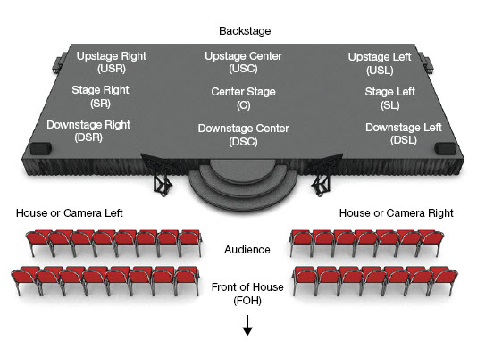

B.
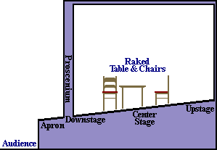

- Locations/Parts of a Stage (See Pictogram A & B)
  - Stage Left
  - Stage Right
  - Upstage
  - Downstage
  - Center Stage
  - Off Stage
  - Back Stage

- Roles in a Theatre Production (Also See Diagram of Production Map from Yale University)
  - Producer
  - Director
  - Assistant Director
  - Stage Manager
  - Lighting Designer
  - Scenic Designer
  - Sound Designer
  - Costume Designer
  - Hair/Make Up Designer
  - Props Master
  - Technical Director
  - Assistant Stage Manager
  - Lighting Technician
  - Sound Technician
  - Lighting Crew
  - Sound Crew
  - Back Stage Crew
  - Costume Crew
  - Actors

- Other
  - Green Room
  - The Scottish Play
  - “Break a Leg”
  - The Ghost Light
  - Blocking
  - Choreography

